Running NextFlow Offline: ONT-Seq-Analysis

For information about the pipeline please see here: [CDCgov/ONT-Seq-analysis: ONT-Seq-analysis is a specialized pipeline designed for analyzing Oxford Nanopore Technologies (ONT) sequencing data from Mpox isolates. It performs reference-based assemblies, identifies variants, designates clades, and generates a detailed quality control (QC) report.](https://github.com/CDCgov/ONT-Seq-analysis)

**Combability:**

Environment where you are running the pipeline, must already have nextflow and docker/singularity installed. See links for installation information:

WSL Nextflow installation guide: [Setting up a Nextflow environment on Windows 10 | Seqera](https://seqera.io/blog/setup-nextflow-on-windows/)

Nextflow installation guide: [Installation — Nextflow documentation](https://www.nextflow.io/docs/latest/install.html)

Nextflow environment setup guide: [Environment setup — Nextflow documentation](https://www.nextflow.io/docs/latest/developer-env.html)

**Configuring for Offline Usage after NextFlow has been Installed:**

1. In location of choice, clone pipeline from github.

git clone https://github.com/CDCgov/ONT-Seq-analysis.git

1. In location of choice, change permissions of directory to ensure executability.

chmod +x ~/path/to/cdcgov-ont-seq-analysis_main/

1. Ensure that additional python script is executable (additional asset python scripts should also be handled like this if used (see bin))

chmod +x ~/path/to/cdcgov-ont-set-analysis_main/main/bin/check_samplesheet.py

1. Modify resource allocation to fit your needs. (If running on a cluster, skip.)
   1. All processes are currently adapted to run on a cluster with abundant computational resources. To run on a local machine or offline these will need to be modified. See link for computational capacity per process or last page of document: [ONT-Seq-analysis/conf/base.config at main · CDCgov/ONT-Seq-analysis](https://github.com/CDCgov/ONT-Seq-analysis/blob/main/conf/base.config)
   2. EXAMPLE PROCESS TO MODIFY RESOURCE ALLOCATION
      1. Open ~ONT-Seq-analysis/modules/nf-core/trimmomatic/main.nf
         1. Make modifications in process definition label

**ORIGINAL:**

process TRIMMOMATIC {

tag "$meta.id"

label 'process_medium'

**MODIFIED:**

process TRIMMOMATIC {

tag "$meta.id"

label 'process_low' #nothing else needs to be modified

* + - 1. Save file
      2. Repeat as needed
  1. Recommended for offline usage by module (all from ONT-Seq-analysis/modules/nf-core/*MODULE*/main.nf)
     1. FASTQC ‘process_low’
     2. IVAR_CONSENSUS ‘process_low’
     3. MINIMAP2_ALIGN ‘process_low’
     4. SAMTOOLS_SORT 'process_low'
     5. TRIMMOMATIC 'process_low'
        1. Optional parameters to modify
           1. IVAR_VARIANTS ‘process_low’
           2. MEDAKAMODULE* ‘process_low’

*in /modules/local/medakamodule

**Running Offline (also see Read.me):**

General Usage:

Nextflow run ~/path/to/ONT-Seq-analysis \

-profile <docker/singularity/…/institute> \

--input sampleshee.csv \

--outdir <OUTDIR> \

-resume <#if applicable> \

--fasta <fasta_path*> \

--bed_file <bed_path*> \

--fai_file <fai_path*> \

--gff_file <gff_path*> \

--mmi_file <mmi_path*> \

--nextclade_dataset_name ‘nextstrain/mpox/all-clades’

*The biggest issues will be with file paths, to avoid this write out full file path, not relative to working directoy; all reference information is available in ONT-Seq-analysis/assests/references/NC063383/ you can point to these files

**Recommended Steps**

1. Once fastq data is available, create a samplesheet.csv
   1. We have written scripts to help with this
      1. If fastq files are already concated by barcode
         1. Script 1: /assets/create_samplesheet.sh
      2. If fastq files are not concated by barcode
         1. Script 2: /assets/ont_fastq_concat_and_samplesheet_create.sh
   2. Run the nextflow pipeline using the general usage example from above.
   3. Additional filtering of NextClade output data available (see Read.me)

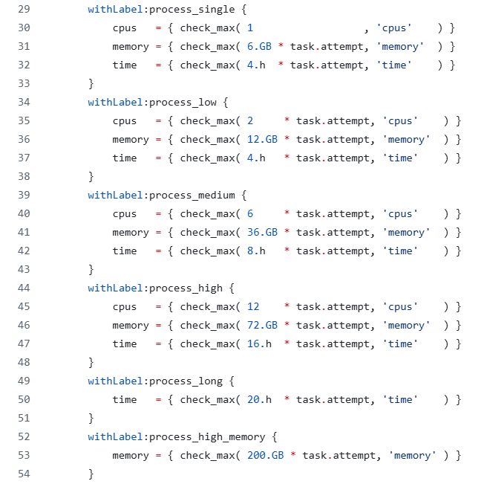Process labels to modify for your machine: